Compiler Construction Project – Phase 2 (Syntax Analyzer)

Project Title: Compiler Construction – Project Phase 2
Project Topic: Syntax Analyzer for Football-Based Mini Language
Student Name: Shahzar Saeed Dar
Roll / Registration Number: L1S22BSCS0107
Course: Compiler Construction
Instructor: Ms. Aneela Mehmood
University: University Of Central Punjab
Section: G15
Submission Date: 17/01/2026

Introduction
Compiler construction is the study of how high-level programming languages are translated into machine-understandable instructions. A compiler is divided into multiple phases, where each phase performs a specific task.
Phase 02 of this project focuses on Syntax Analysis, which is the second phase of the compiler. The syntax analyzer (parser) checks whether the sequence of tokens produced by the lexical analyzer follows the grammatical rules of the language.
In this project, a custom football-based Mini language was designed in Phase 01. Phase 02 validates the structure of programs written in that language using formal grammar rules implemented through YACC/Bison.

Overview of the Football-Based Language
The custom language designed for this project is based on a football theme to ensure originality and creativity. All keywords, operators, and punctuations were inspired by football terminology while maintaining programming semantics.
The same language created in Phase 01 is reused in Phase 02 without changing any previously defined tokens. Only new grammar rules are added to describe how valid programs can be formed using these tokens.
Unique Keywords of the language
Keyword | Meaning (for explanation)
kickoff | program start
halftime | mid-block
fulltime | program end
goal | return
pass | assignment
shoot | output
defend | if
attack | else
replay | loop
lineup | function
striker | int
winger | float
keeper | char
referee | bool
VAR | true
offside | false

Operators (Custom)

Operator | Meaning
==> | assignment
+++ | increment
&&& | logical AND

Punctuations (Custom)

Punctuation | Purpose
< > | block start/end
:: | scope resolution

Token Reuse from Phase 01
This phase strictly reuses the lexical analyzer developed in Phase 01. No tokens were renamed, removed, or modified. The parser directly receives tokens from the scanner and uses them for syntax validation.
Reused Token Categories:
- Keywords (kickoff, fulltime, striker, defend, attack, shoot)
- Identifiers (ID)
- Numbers (NUMBER)
- Operators (==>, +++)
- Punctuations (<, >)
This ensures complete compatibility between the lexical analyzer and the syntax analyzer.

Context Free Grammar (CFG)
Match → KICKOFF < event_list > FULLTIME

event_list → event event_list
event_list → event

event → lineup_event
event → pass_event
event → defend_event
event → replay_event
event → shoot_event

lineup_event → STRIKER ID
lineup_event → WINGER ID
lineup_event → KEEPER ID

pass_event → ID ASSIGN play_value

play_value → NUMBER
play_value → ID

defend_event → DEFEND < event_list > attack_event_opt

attack_event_opt → ATTACK < event_list >
attack_event_opt → ε

replay_event → REPLAY < event_list >

shoot_event → SHOOT STRING

Supported Statement Types
The language supports five different statement types:
Declaration Statement: Used to declare variables.
lineup_event → STRIKER ID
| WINGER ID
| KEEPER ID
Assignment Statement: Used to assign values to variables.
pass_event → ID ASSIGN play_value
Conditional Statement: Used for decision making.
defend_event → DEFEND < event_list > attack_event_opt
attack_event_opt → ATTACK < event_list >
| ε

Loop Statement: Used for repetition.

replay_event → REPLAY < event_list >
Output Statement: Used to display output.
shoot_event → SHOOT STRING

FIRST and FOLLOW Sets
FIRST and FOLLOW sets are used to understand how parsing decisions are made.
FIRST (Match) = {KICKOFF}
FOLLOW (Match) = {$}

FIRST (event_list) = {STRIKER, WINGER, KEEPER, ID, DEFEND, REPLAY, SHOOT}
FOLLOW (event_list) = {>}

FIRST (event) = {STRIKER, WINGER, KEEPER, ID, DEFEND, REPLAY, SHOOT}
FOLLOW (event) = {STRIKER, WINGER, KEEPER, ID, DEFEND, REPLAY, SHOOT, >}

FIRST (pass_event) = {ID}
FOLLOW (pass_event) = {STRIKER, WINGER, KEEPER, ID, DEFEND, REPLAY, SHOOT, >}

FIRST (replay_event) = {REPLAY}
FOLLOW (replay_event) = {STRIKER, WINGER, KEEPER, ID, DEFEND, REPLAY, SHOOT, >}
These sets confirm that the grammar is suitable for top-down parsing.

Parse Tree (Valid Program)
This page contains the parse tree of a valid football-based program written using the defined grammar.
The parse tree visually represents how the start symbol expands into terminals according to the grammar rules. Each internal node represents a non-terminal, while leaf nodes represent tokens.

Sample Valid Program
kickoff
<
striker score
score ==> 5
shoot "Goal"
>
fulltime
Grammar Rules Used
Match → kickoff < event_list > fulltime
event_list → event
event → lineup_event
lineup_event → STRIKER ID

Parse Tree (Hand-Drawn)
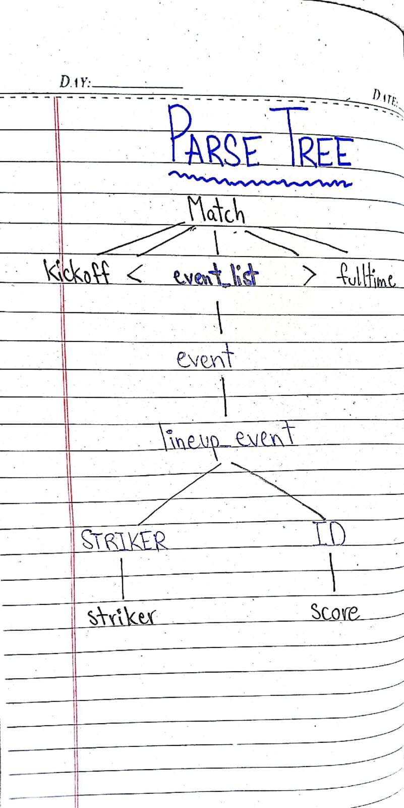

Error Handling Strategy
Syntax errors are handled using the yyerror function in YACC. When a syntax error occurs, the parser reports the line number and the nature of the error.
Two types of errors are demonstrated:
- Missing token error (e.g., missing identifier)
- Invalid statement structure error
This helps in identifying grammatical mistakes in the program during parsing.

Sample Programs Reference
Two test programs were created for validation:
- One valid program that follows all grammar rules
- One invalid program that produces a syntax error
These programs are provided as separate files and are used during parser execution and demo.

Conclusion
This project successfully implements a syntax analyzer for a custom football-based language using YACC/Bison. The parser correctly validates program structure, integrates with the lexical analyzer, and reports syntax errors with line numbers.
Through this project, concepts such as grammar design, parsing, FIRST/FOLLOW sets, and compiler front-end integration were practically implemented.

Github Link for all the files: https://github.com/shahzardar555/compiler-construction-football-language/tree/main

